Below is a step by step guide with images to show you how you can save pictures stored on your computer to your google drive.
- First, you will need to log into your google account provided by the district.
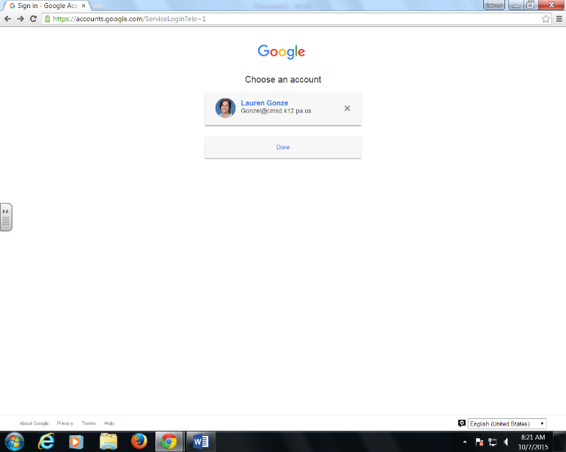

- Once logged in, you will need to select the drop down button for your google apps. Select your google drive.

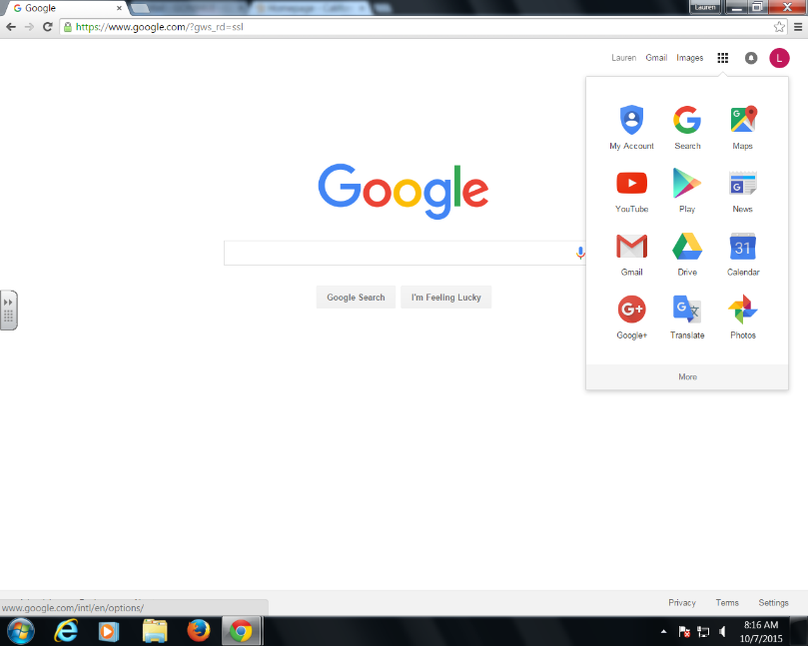

- You will be taken to a screen that looks similar to the one below. Your screen may have documents already stored in your drive.
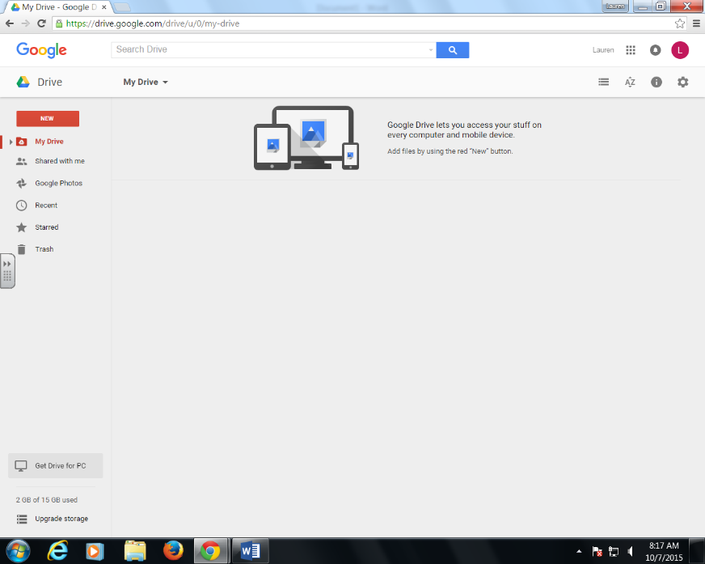

- On the left side of the page, under drive, select new. Then, select file upload.
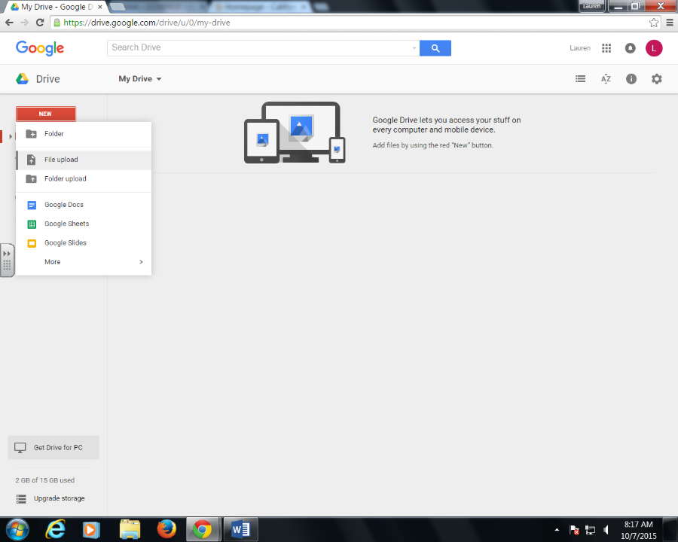

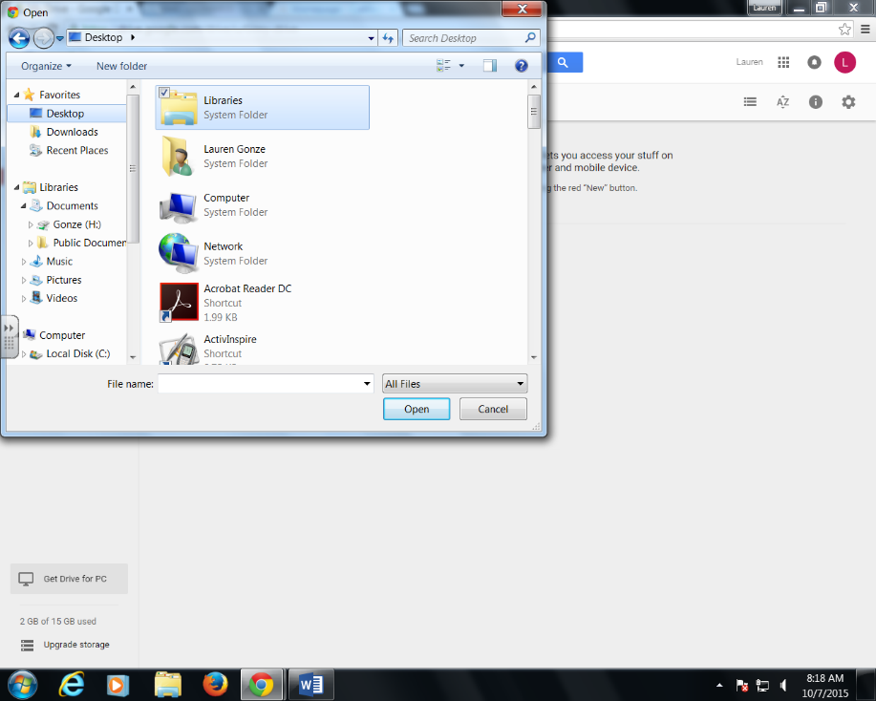
- A new tab will open. From here, you will need to select the storage file on your computer where the images you wish to save to your google drive are stored.

- Once you have selected the file where your pictures are stored, select the pictures that you wish to upload to your google drive.
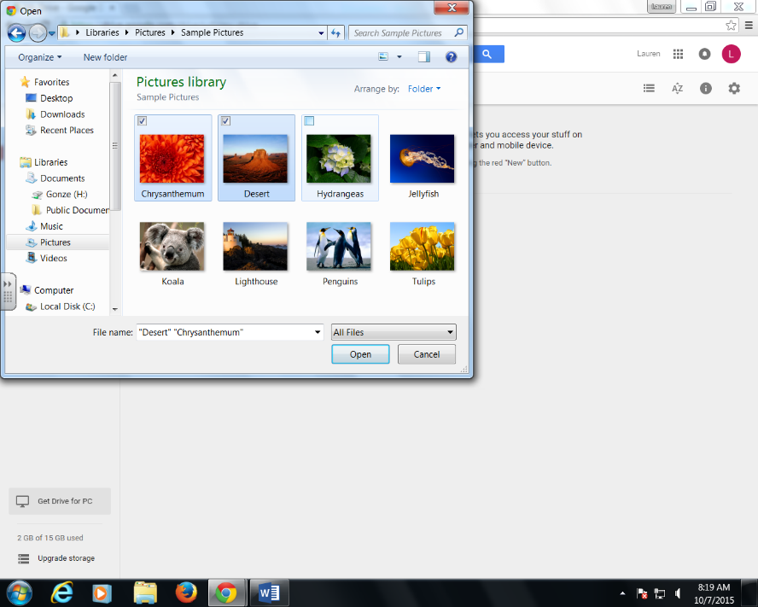

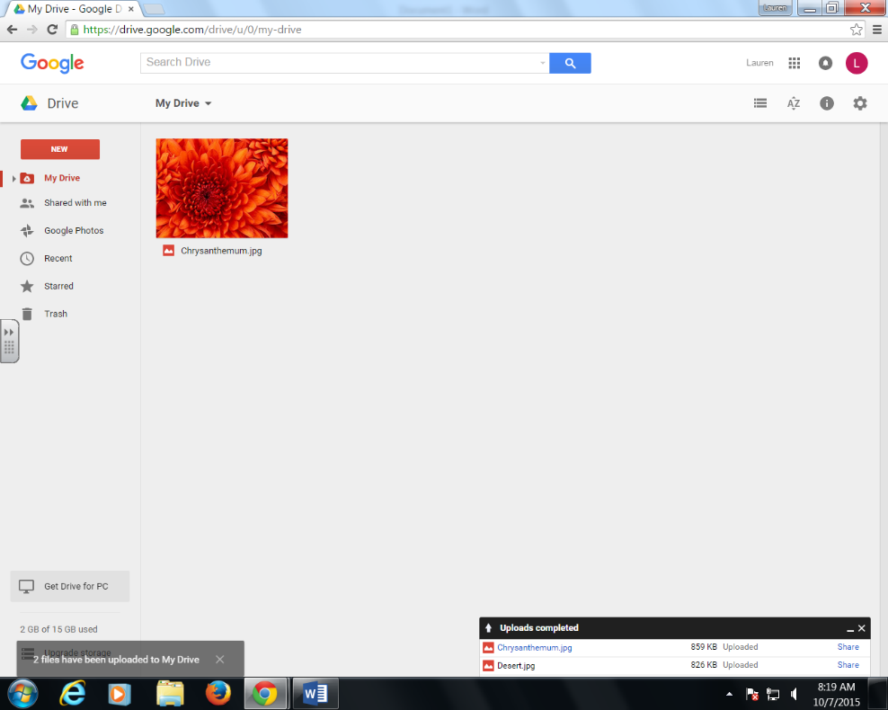
- You will be directed back to your google drive. At the bottom, right-hand corner of your screen, you should see the documents you selected being uploaded to your google drive.

- That is it. Now any pictures you uploaded are saved to your google drive and will be available to you when you sign into your google account.

